**Mainframe and Midrange Db2 Applications accessing Azure SQL Databases**

This solution outlines a way for IBM mainframe and midrange applications to access remote Azure databases. The approach requires zero or minimal changes in application code.

IBM Db2 clients and servers use the Distributed Relational Database Architecture (DRDA) protocol to communicate. In this solution, Microsoft Service for DRDA connects Db2 clients on IBM z/OS and IBM i to SQL Server–based databases by supporting this protocol.

**Potential use cases**

Various scenarios can benefit from this solution:

* *Coexistent* environments that have modernized data as part of a [data-first](http://www.enterpriseappstoday.com/data-management/5-reasons-a-data-first-strategy-works.html) migration but still run mainframe or midrange applications.
* *Hybrid* situations, or environments that combine on-premises and cloud datacenters. This case covers systems with mainframe applications in COBOL, PL/I, or assembly language that need access to an SQL Server database hosted in Azure.
* Mainframe or midrange systems with workloads that need remote access to SQL Server databases.

**Architecture**

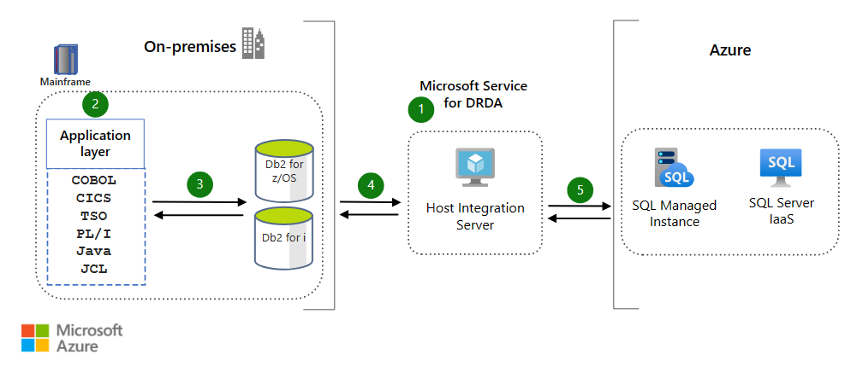

*Download a*[*Visio file*](https://arch-center.azureedge.net/mainframe-access-azure-databases-architecture.vsdx)*of this architecture.*

1. Host Integration Server (HIS) software runs on an on-premises or Azure virtual machine (VM). HIS connects IBM systems with Azure systems.
2. Mainframe and midrange applications run on the on-premises system. These applications use languages and environments like COBOL, CICS, TSO, PL1, Java, and JCL. The solution involves adjusting the Db2 database configuration. The applications can then access Azure databases in the same way that they access local mainframe or midrange tables.
3. A mainframe or midrange application sends a SQL request to the local Db2 subsystem. Db2 configurations reroute the request to the HIS server.
4. The HIS server receives the request and forwards it to the target database. Microsoft Service for DRDA is a component of HIS that functions as a DRDA Application Server (AS). In this role, Microsoft Service for DRDA converts the Db2 SQL statements and runs them on the Azure database.
5. The target database handles the request. This solution can configure the following target databases:
   * Azure SQL Database, which offers the benefits of a fully managed platform as a service (PaaS).
   * SQL Server on Azure Virtual Machines. As an infrastructure as a service (IaaS) offering, this service provides a customizable database engine.
   * SQL Server, a database engine for structured and unstructured data.

These database services can also form the core of business intelligence solutions that offer analytics and insights.

**Components**

This solution uses the following components. See the [Azure pricing calculator](https://azure.microsoft.com/pricing/calculator) to estimate costs for Azure resources.

**Data stores**

* [SQL Database](https://learn.microsoft.com/en-us/azure/azure-sql/database/sql-database-paas-overview) is a relational database service that's part of the [Azure SQL](https://learn.microsoft.com/en-us/azure/azure-sql/azure-sql-iaas-vs-paas-what-is-overview) family. As a fully managed service, SQL Database handles database management functions like upgrading, patching, backups, and monitoring. SQL Database also provides AI-powered, automated features that optimize performance and durability. Serverless compute and Hyperscale storage options automatically scale resources on demand.
* [SQL Server on Azure Virtual Machines](https://learn.microsoft.com/en-us/azure/azure-sql/virtual-machines/windows/sql-server-on-azure-vm-iaas-what-is-overview) provides a way to migrate SQL Server workloads to the cloud with 100 percent code compatibility. As part of the Azure SQL family, SQL Server on Azure Virtual Machines offers the flexibility and hybrid connectivity of Azure. But this database solution also provides the performance, security, and analytics of SQL Server. With SQL Server on Azure Virtual Machines, you can migrate existing apps or build new apps. You can also access the latest SQL Server updates and releases.
* [SQL Server](https://learn.microsoft.com/en-us/sql/sql-server) provides a solution for storing and querying structured and unstructured data. This database engine features industry-leading performance and security.

**Tools**

* [HIS](https://learn.microsoft.com/en-us/host-integration-server/what-is-his) software connects IBM systems with Azure systems. HIS runs on an on-premises or Azure VM. HIS provides integration services for networks, data, applications, messaging, and security features.
* [Microsoft Service for DRDA](https://learn.microsoft.com/en-us/host-integration-server/what-is-his#Data) is a component of HIS. Microsoft Service for DRDA is an Application Server (AS) that DRDA Application Requester (AR) clients use. Examples of DRDA AR clients include IBM Db2 for z/OS and Db2 for i. These clients use the AS to convert Db2 SQL statements and run them on SQL Server.

**Contributors**

*This article is maintained by Microsoft. It was originally written by the following contributors.*

Principal authors:

* [Nithish Aruldoss](https://www.linkedin.com/in/nithish-aruldoss-b4035b2b) | Engineering Architect
* [Ashish Khandelwal](https://www.linkedin.com/in/ashish-khandelwas-839a851a3) | Senior Engineering Architect

*To see non-public LinkedIn profiles, sign in to LinkedIn.*

**Next steps**

* For general information on mainframe modernization and database migration:
  + Contact Azure Data Engineering - Mainframe & Midrange Modernization at [datasqlninja@microsoft.com](mailto:datasqlninja@microsoft.com).
  + See [Azure Database Migration Guides](https://learn.microsoft.com/en-us/data-migration).
  + See [Planning and architecting solutions using Microsoft Service for DRDA](https://learn.microsoft.com/en-us/host-integration-server/core/planning-and-architecting-solutions-using-microsoft-service-for-drda).
  + See [Migrate databases and data](https://learn.microsoft.com/en-us/azure/cloud-adoption-framework/infrastructure/mainframe-migration/application-strategies#migrate-databases-and-data).
* For implementation information:
  + See [Install and configure HIS 2020](https://learn.microsoft.com/en-us/host-integration-server/install-and-config-guides/installing-his-2020).
  + Learn how to [add information on a target database to an HIS server configuration](https://learn.microsoft.com/en-us/host-integration-server/core/configuring-sql-server-connections).
  + See how to [configure a Db2 database to reroute requests to an HIS server](https://learn.microsoft.com/en-us/host-integration-server/core/configuring-db2-for-z-os).

**Related resources**

* [Mainframe file replication and sync on Azure](https://learn.microsoft.com/en-us/azure/architecture/solution-ideas/articles/mainframe-azure-file-replication)
* [Replicate and sync mainframe data in Azure](https://learn.microsoft.com/en-us/azure/architecture/reference-architectures/migration/sync-mainframe-data-with-azure)
* [Modernize mainframe and midrange data](https://learn.microsoft.com/en-us/azure/architecture/example-scenario/mainframe/modernize-mainframe-data-to-azure)
* [Migrate IBM mainframe applications to Azure with TmaxSoft OpenFrame](https://learn.microsoft.com/en-us/azure/architecture/solution-ideas/articles/migrate-mainframe-apps-with-tmaxsoft-openframe)